

**USER’S**

**MANUAL**

*Webpage Implementation*

**for ABC Learning Centre**

Prepared by: Daniel Seah

May, 2019

**Revision Sheet**

|  |  |  |
| --- | --- | --- |
| **Release No.** | **Date** | **Revision Description** |
| Version 0 | 31/05/2019 | Created User Document |
| Version 1 | 01/06/2019 | Added Setting up FileZilla Client and navigation pages |
| Version 1.1 | 05/06/2019 | Changed images and added new changes done on the webpages |
|  |  |  |
|  |  |  |
|  |  |  |

**USER'S MANUAL**

**TABLE OF CONTENTS**

Page #

1.0 GENERAL INFORMATION 1-1

1.1 System Overview 1-1

2.0 SYSTEM SUMMARY 2-1

2.1 System Configuration 2-1

3.0 GETTING STARTED 3-1

3.1 Setting up FileZilla Client 3-1

3.2 Uploading Webpages 3-4

3.3 Navigating Around the Webpages 3-4

**1.0 GENERAL INFORMATION**

# GENERAL INFORMATION

## 1.1 System Overview

The world today trades vast amounts of information through the internet. In the past, static webpages were presented to users. Such conventional methods required large amount of files to be present on the server which made maintenance tedious and difficult. Pages had to be constantly refreshed for new content to be displayed.

Today, however, with the presence of modern tools such as JavaScript and its libraries, Single Page Application (or SPA) have become an adopted approach to presenting information. SPAs, in contrast to conventional methods, only has a main page loaded. Additional content, which are small parts of webpages are then requested from the server when needed via Asynchronized Javascript and XML (Ajax). The newly received information replace the original content on the main page. No refreshes occurs during this time.

The webpages supplied to ABC Learning Centre uses a SPA to provide information. This SPA is hosted on a server (Apache) to work.

**2.0 SYSTEM SUMMARY**

# SYSTEM SUMMARY

## 2.1 System Configuration

The webpages consists of the main page content with its categories, along with images, stylesheets and scripts to utilize Javascript. These files are to be hosted on a server where the webpages will function. Uploading these files can be done via FileZilla Client.

**3.0 GETTING STARTED**

# GETTING STARTED

## 3.1 Setting up FileZilla Client

First, we install FileZilla Client

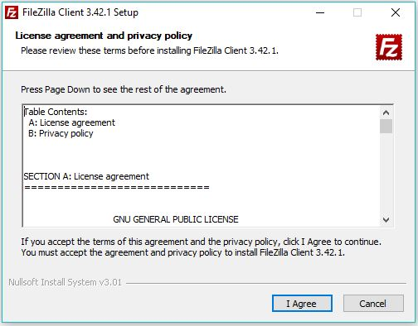

-Click the “I Agree” button to begin installation

-Click “Next >” twice

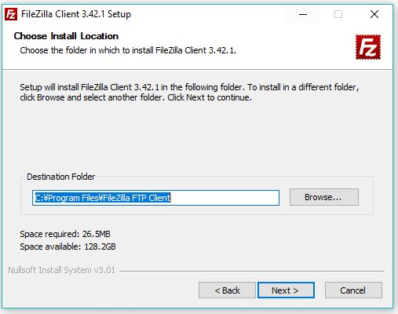

-Choose your installation Location

-Click “Next >” on the Configuration Wizard to start installing

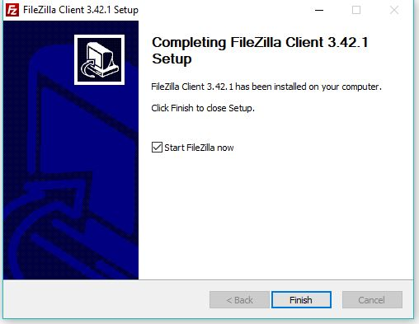

-Click Finish to start FileZilla Client. Alternatively you may start FileZilla at a later time by unchecking the “Start” FileZilla Now” box.

## 3.2 Uploading Webpages

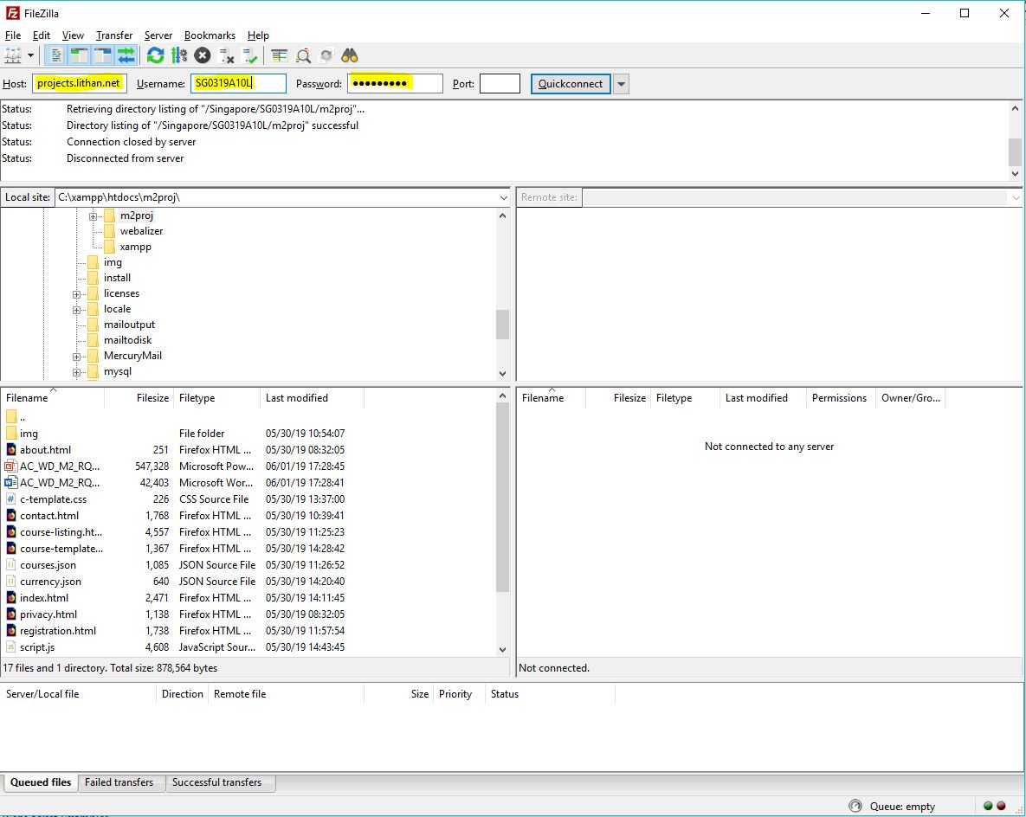

-Enter the Server Host, username and password and click “Quickconnect”

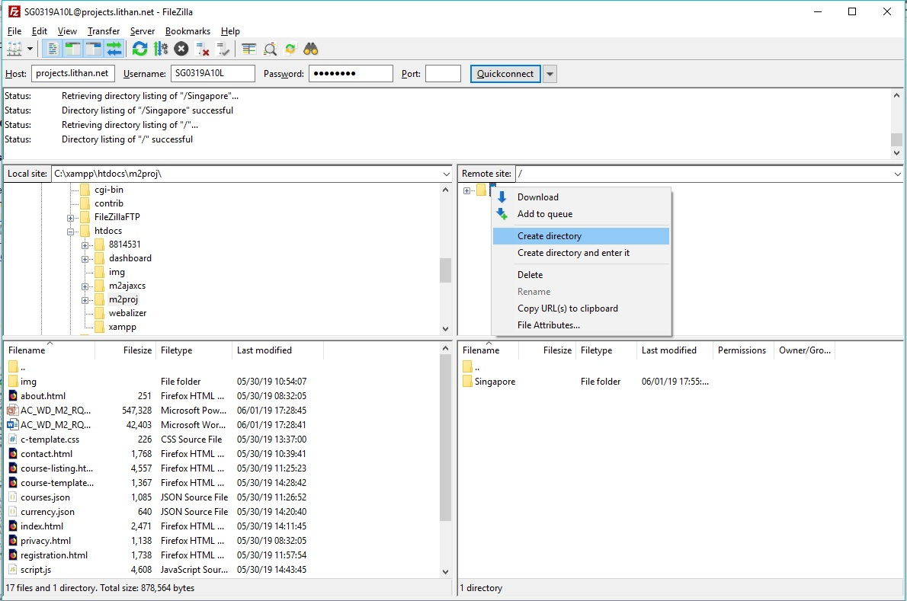

-Create the necessary file directory on the server by right clicking at the right panel as shown on the image

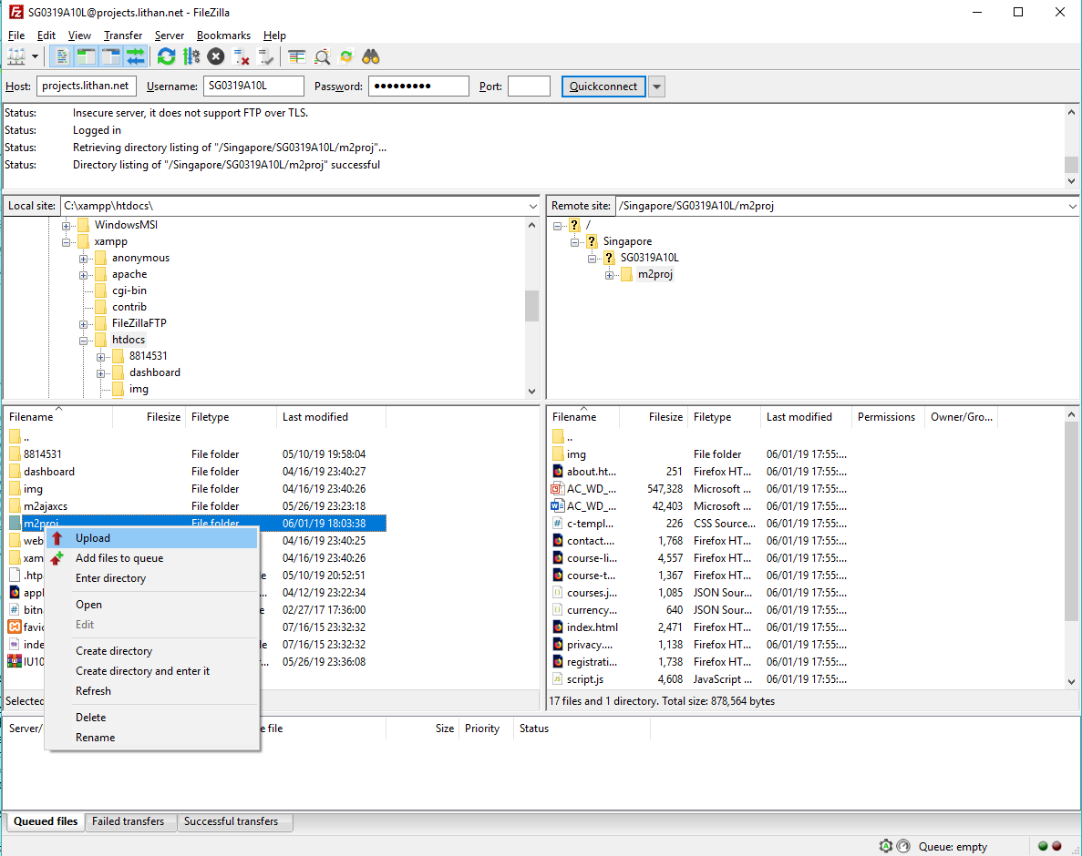

-Right click on the files or folders and click on “Upload”

## 3.3 Navigating Around the Webpages

## 

This is the Homepage of ABC Learning Centre. The top navigation bar has 5 links:

-ABC Learning Logo (Goes back to this Homepage)

-Contact us (Goes to Contact us Form)

-About us (Goes to page talking about

-Course Listing

-Registration Form

At the bottom navigation there are related links to other sides and finally a site-map and privacy policy links.

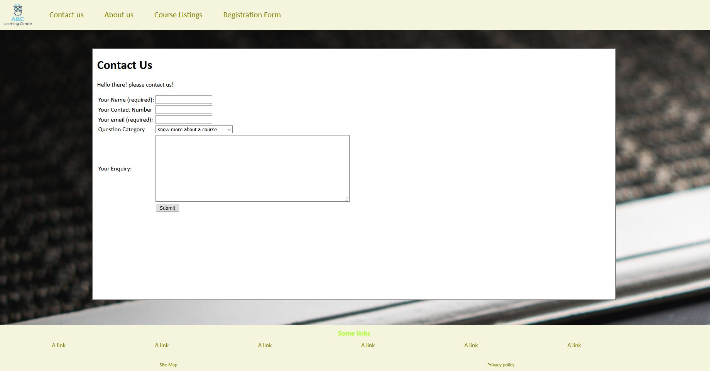

-This is the contact page where customer enquires can be made.

-Enquires types can be chosen from the category list.

-A Thank you page is shown when the customer submits the enquiry

*Note: Name and email is mandatory*

This is the Course List page where ABC learning Centre’s available courses are available.

-Clicking on the Brown Headers will bring up the details of the course

This page shows the details of the course, including the description, the course fees and who this course is recommended for.

On the right hand side, a currency converter is available for foreign users to check fees in their native currency.

The available currencies are:

1. SGD
2. MYR
3. PHP
4. INR
5. IDR

If the user is wishes to express interest in this course, the “Register Now!” button leads the user to the websites’ registration form

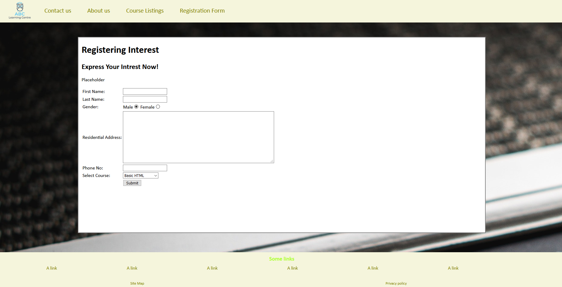

This page is the registration form. Users can arrive at this page either by clicking “Registration Form” on the top navigation bar, or by clicking “Register Now” button previously mentioned.

A “Thank you” page appears when the “submit” button is clicked.

*Note: First name and last name is mandatory.*

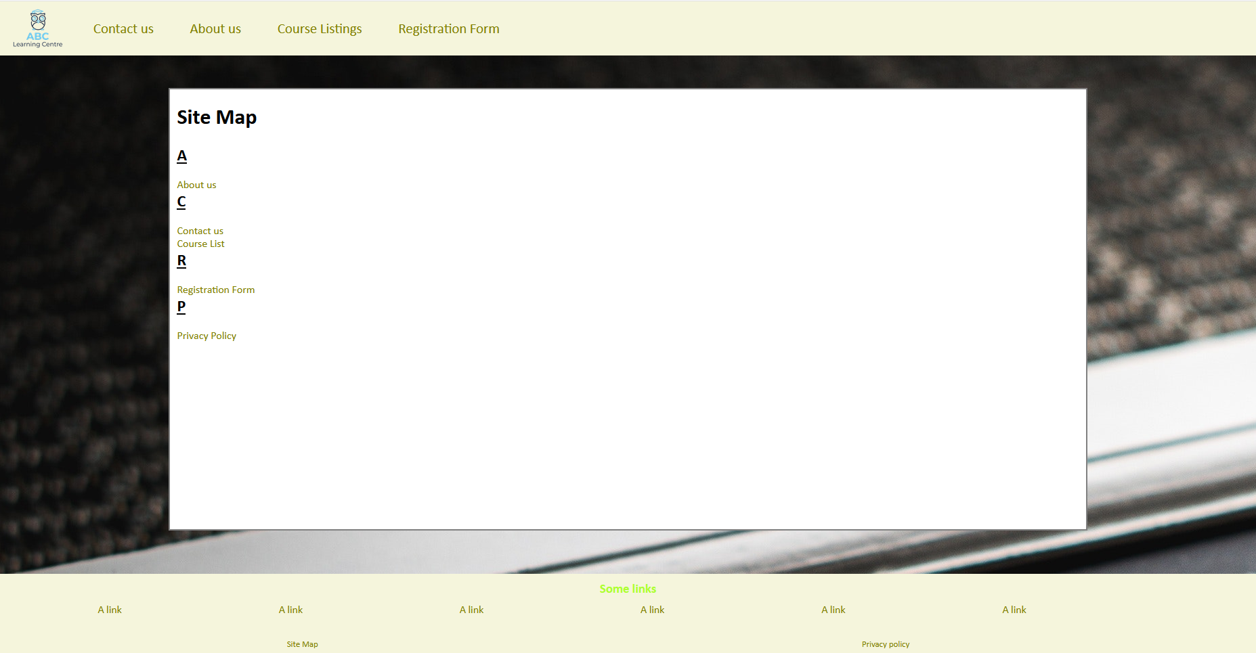

This is the site map where users can easily navigate to webpages.